**Adding Custom Schematic Symbols**

You will get some components that don’t show up correctly in the schematic because they are custom. I have added them in a folder called “Schematic-Symbol-Libraries”. You will have to add that search path in KiCAD so it knows where to look for those custom schematic symbols. First, go to preferences -> component libraries

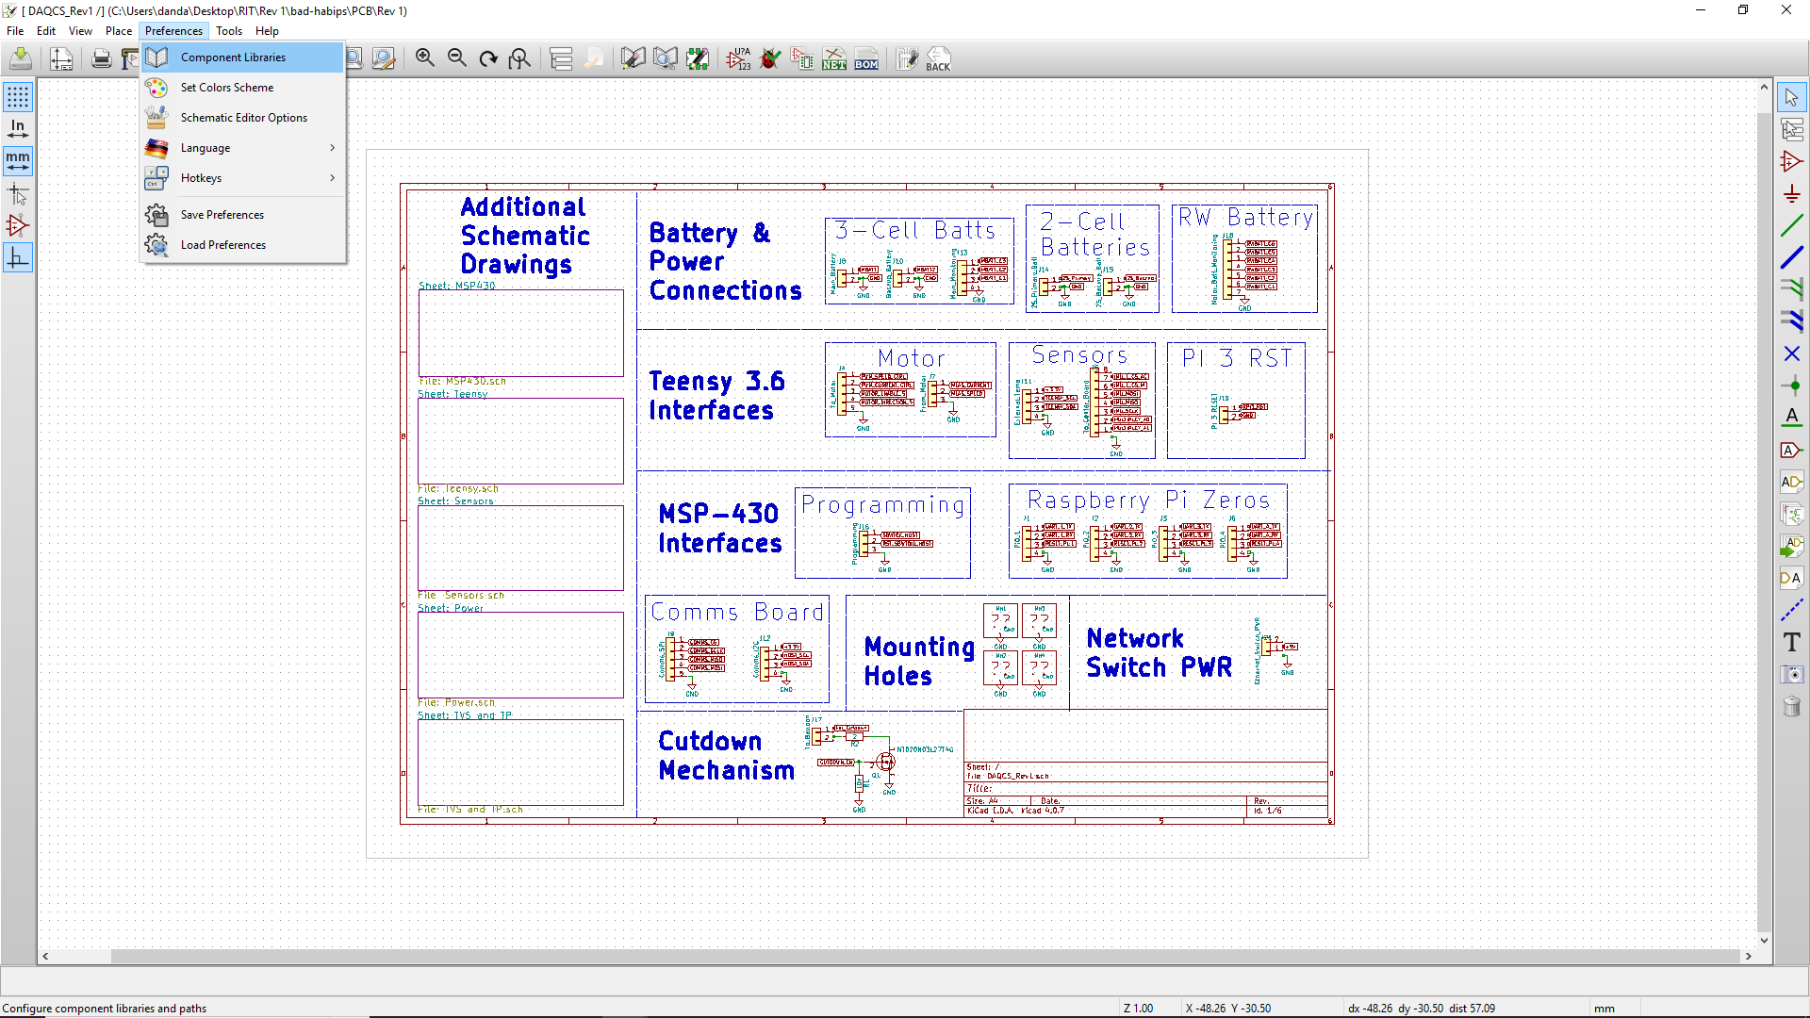

Select “Add” under the “User Defined Path” section

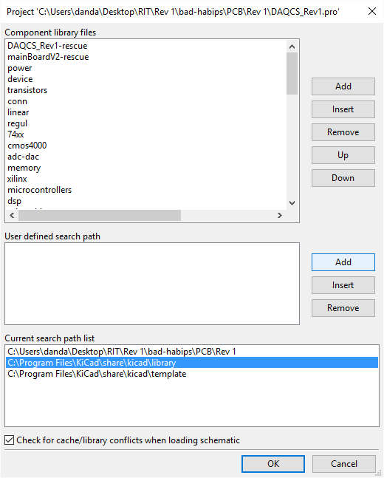

Select the folder that contains the custom symbols

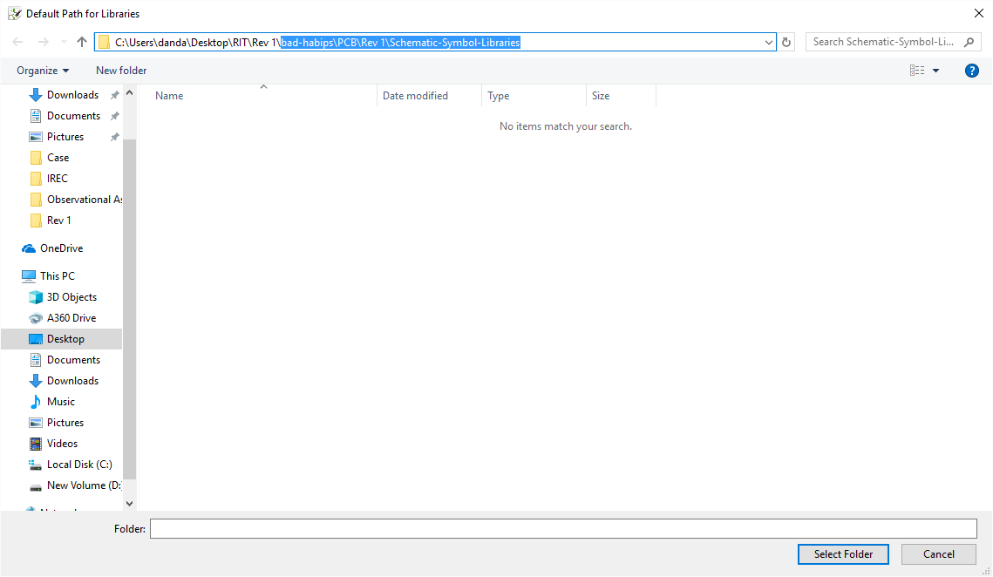

Click “Yes” for using a relative path

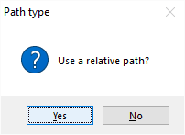

At this point, you should see it appear in the “Current search path list” at the bottom. Click “OK” and then close and reopen the schematic again. You should no longer have an issue with those components not appearing. You will probably still have an issue with KiCAD saying that a “rescue” library wasn’t found, but that is nothing to worry about.